Supplementary information
Extraction, Isolation, Characterization and Antioxidant Potential of Pure Compounds from Adonsonia digitata Leaf extract
By
Hauwa A. Umaru, Isaac John Umaru and Fasihuddin Badruddin Ahmed

Introduction
Adonsonia digitata L. (Malvaceae) commonly known as Baobab is a medicinal and nutritional plant. The plant parts are used to treat various ailments such as diarrhoea, malaria and microbial infections. It is reported that it is an excellent anti-oxidant due to its vitamin C content. Baobab has numerous biological properties including antimicrobial, antiviral, anti-oxidant and anti-inflammatory activities amongst others.
Objective: The study involves extraction, Isolation, Characterisation of phytochemicals and evaluation of antioxidant potential of the pure compounds.

Methods: The dried leaf powder was subjected to rotary evaporator to obtain crude extract which was subjected to isolation using chromatography analysis and elucidation using NMR and FTIR. Antioxidant (IC₅₀) potential was determined using 2,2-diphenyl-1- picryl-hydrazyl-hydrate (DPPH).

Result: Phytochemical investigation of the Baobab leaf extract through isolation and characterization of a bioactive compound was observed. The leaf extract yielded three compound characterised as D-Limonene, Thunbergol and (z)-2-Methyl-7-octadecene.
Conclusion: The analysis of the chemical component reported identified compounds from Baobab leaf as; D-Limonene; (1) Thunbergol (2) and Cis-2-Methyl-7-octadecene (3) with significant antioxidant potential. The chemical components were identified for the first time.

Path for Isolation of pure Compounds
Powdered Sample (2kg)
Extraction of Crude Extract

Serial dilution
Residual
Hexane crude extract

Dichloromethane

DCM
Crude
Chloroform
Crude
Ethyl acetate
Crude
Methanol
Crude
Hexane
Crude
Rota-Vap = Concentrated
Crude extract
Chloroform
Ethyl acetate
Methanol

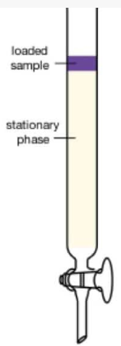
2
TLC fraction
TLC fraction
Medium size Column
45
285.22mg

542.12mg
270.6 mg
D-Limonene

TLC UV Light one spot
FT-IR
NMR
Cis-2-Methyl-7-octadecene
Thunbergol
Elucidation and Characterization
GC-MS one peak

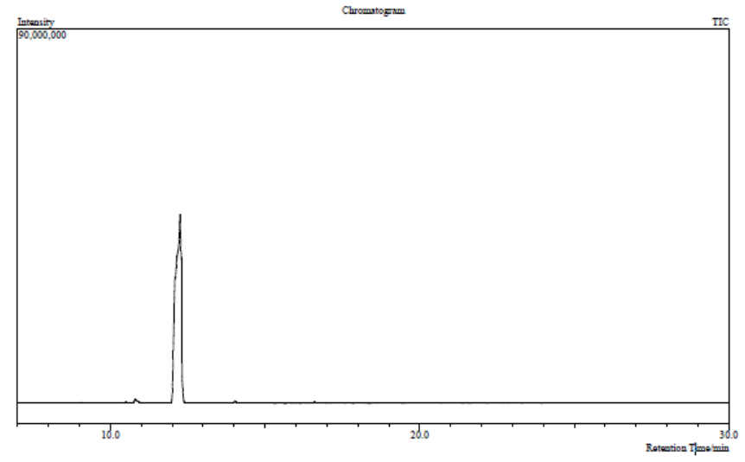
Compound 1 D-limonene
Figure 1: Gas Chromatogram of Compound 1

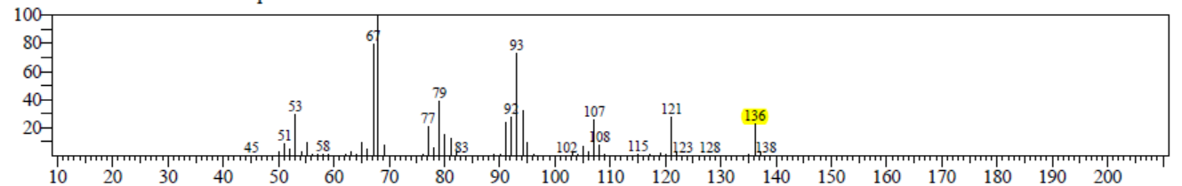
Figure 3: Mass Spectrum of Compound 1
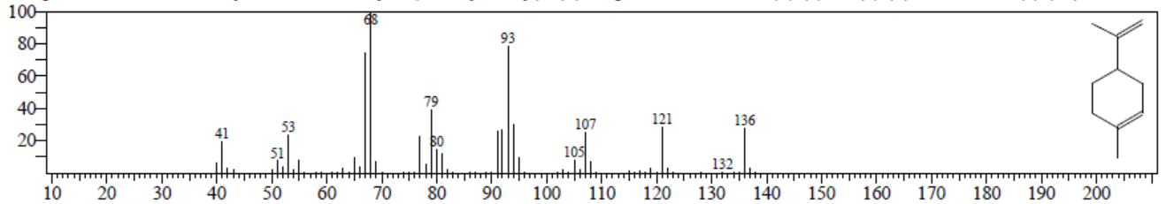
Figure 4: Mass Spectrum of Suggested Structure of Compound 1 by NIST Library

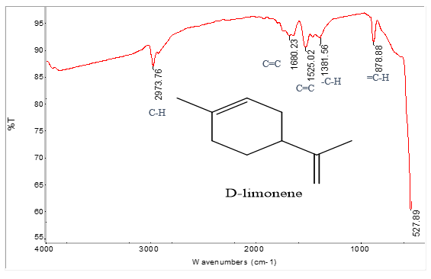
Figure 5: IR spectrum of Compound 1
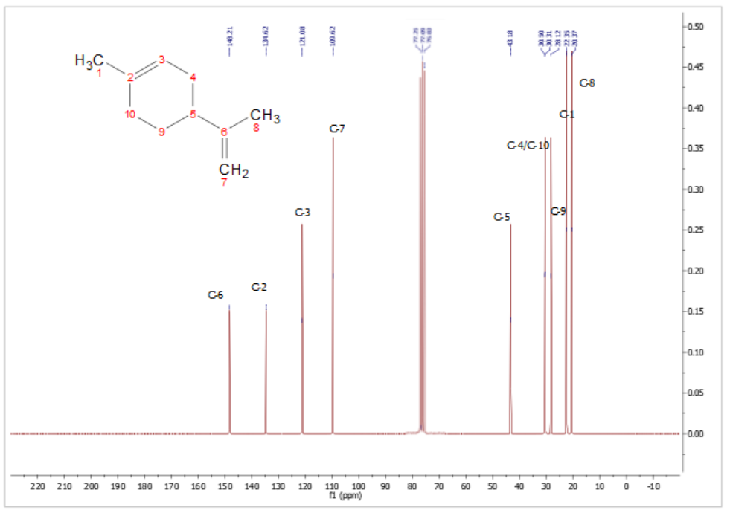
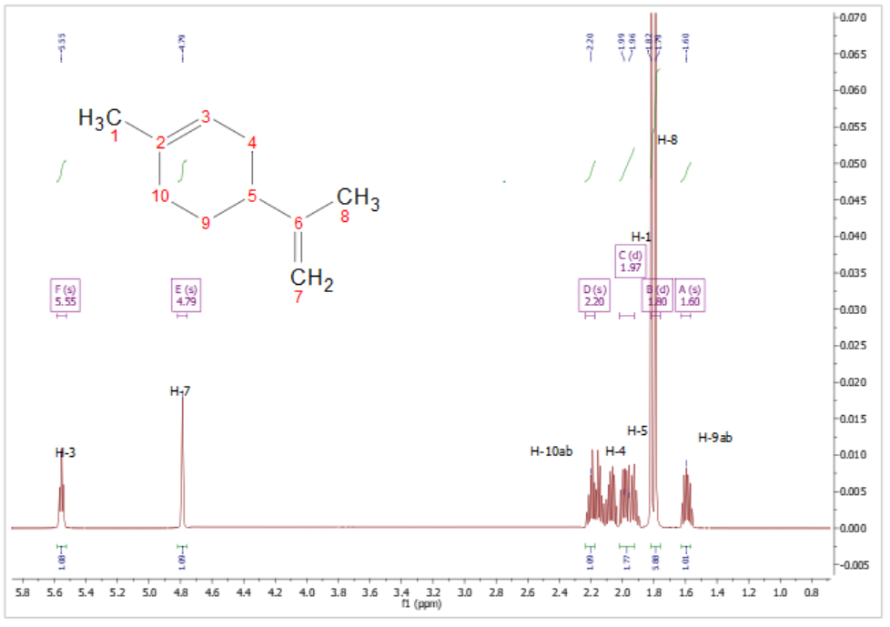
6: ¹H-NMR spectrum of Compound 1 from 0.8 to 5.8 (500 MHz CDCl₃)

Figure 7: ¹³C-NMR spectrum of Compound 1 from -1.0 to 220 (125 MHz CDCl₃)
Compound 2 Thunbergol
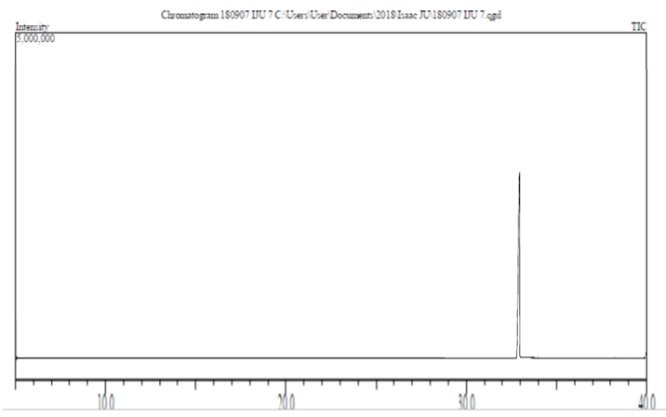
Figure 6: Gas Chromatogram of Compound 2
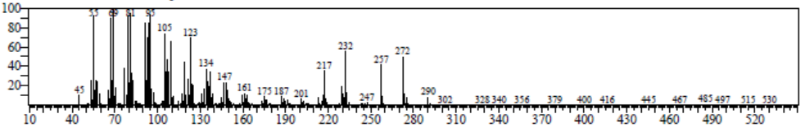
Figure 7: Mass spectrum of Compound 2
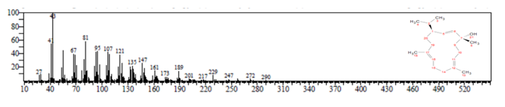
Figure 8: Mass Spectrum of Suggested Structure of Compound 2 by NIST Library

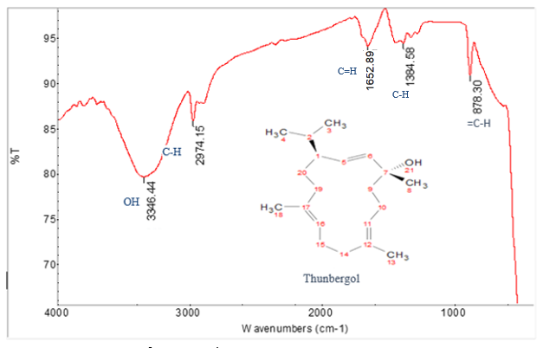
Figure 9: IR Spectrum of Compound 2

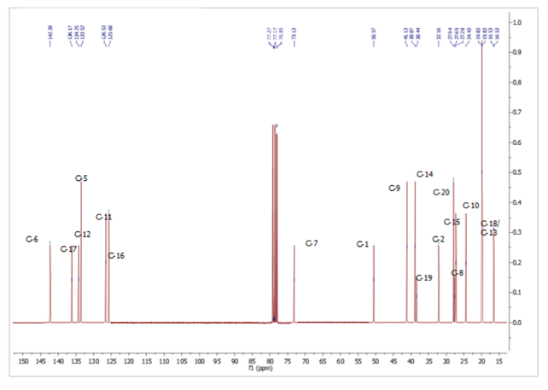
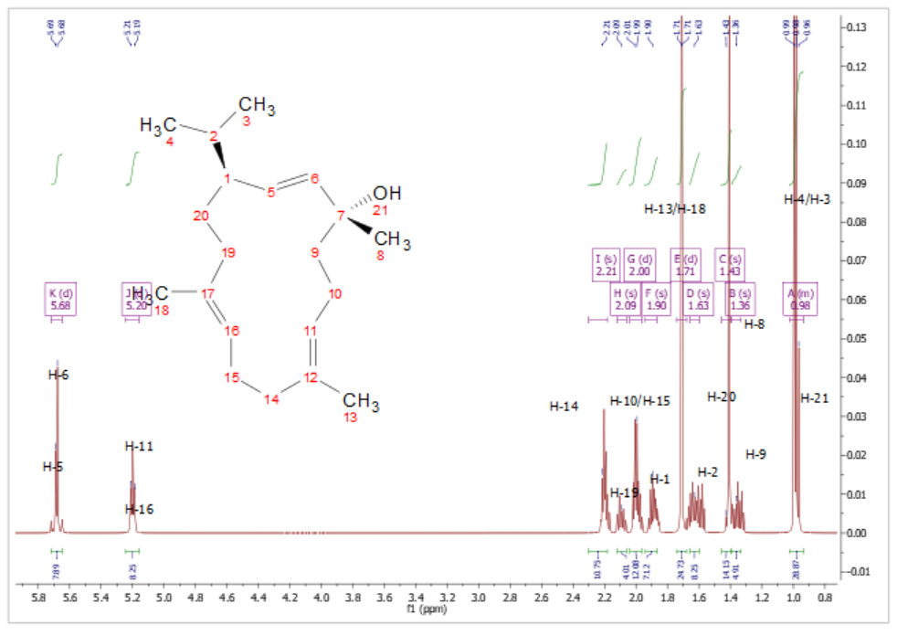
Figure 10: ¹H-NMR spectrum of Compound 2 from 0.8 to 5.8 (500 MHz CDCl₃)
Figure 11: ¹³C-NMR spectrum of Compound 2 from 15 to 150 (125 MHz CDCl₃)

Compound 3 Cis-2-Methyl-7-octadecene
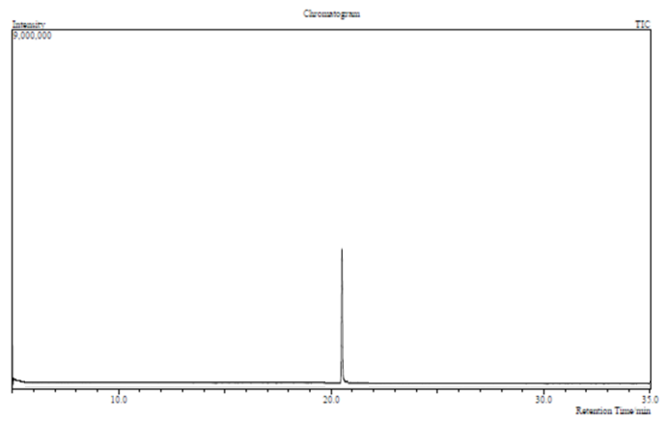
Figure 11: Gas Chromatogram of Compound 3
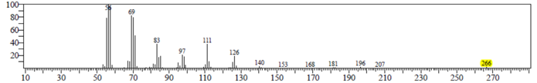
Figure 12: Mass Spectrum of Compound 3

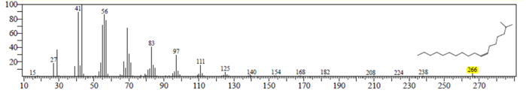
Figure 13: Mass Spectrum of Suggested Structure of Compound 3 by NIST Library.

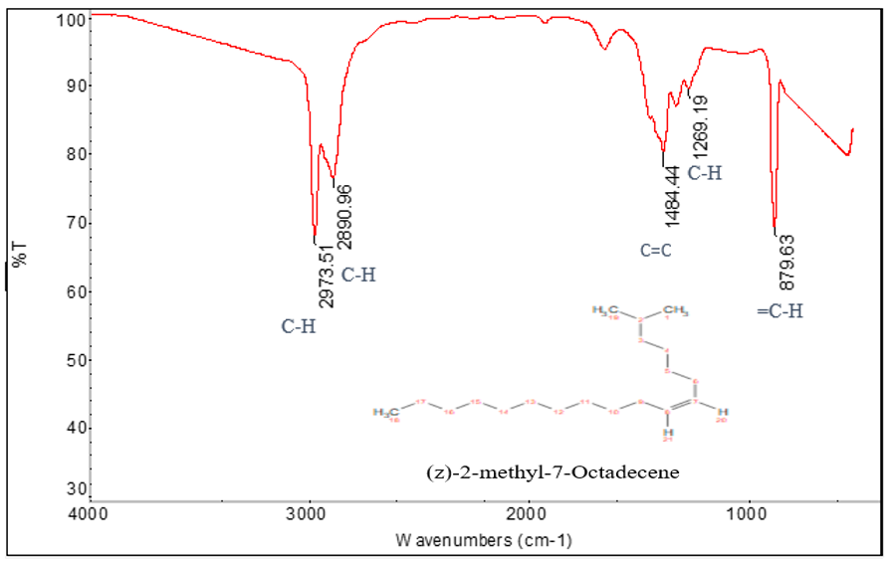
Figure 14: IR Spectrum of Compound 3.
Figure 15: ¹H-NMR spectrum of Compound 3 from -2.0 to 10.0 (500 MHz CDCl₃)
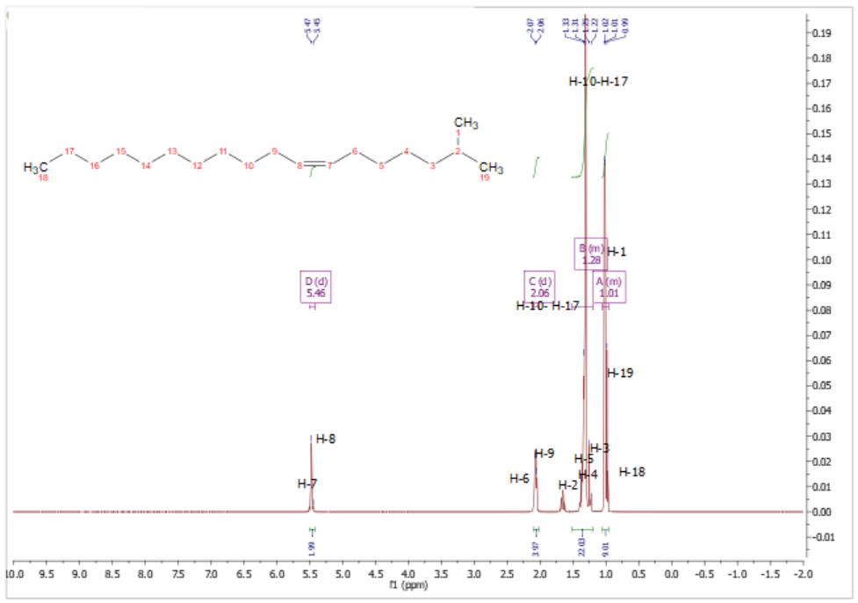
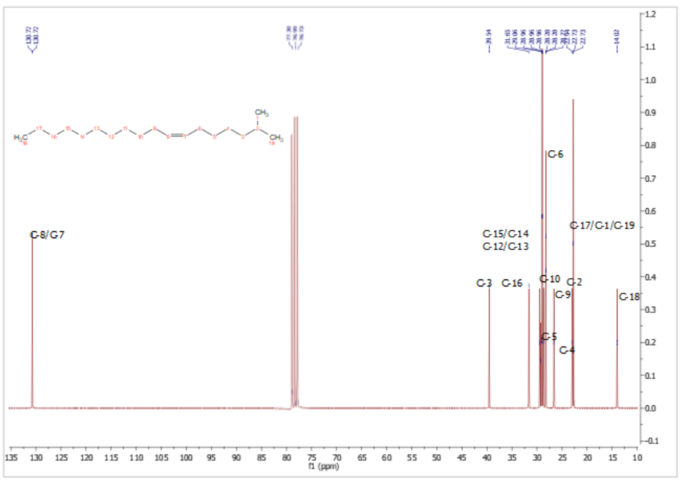
Figure 16: ¹³C-NMR spectrum of Compound 3 from 10 to 135 (125 MHz CDCl₃)
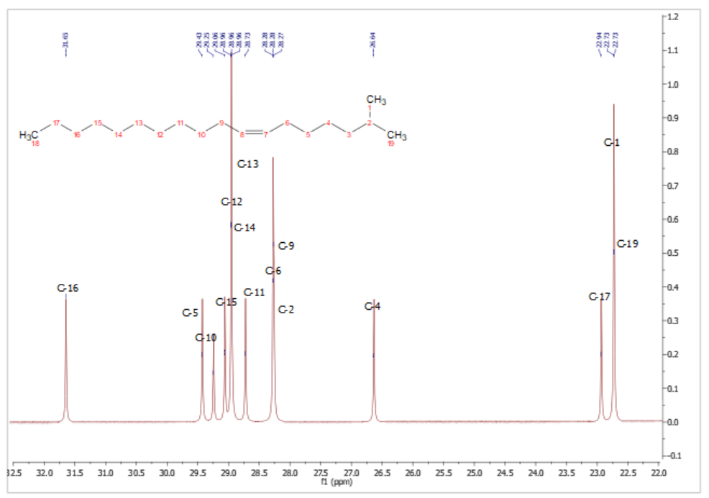
Figure 17: ¹³C-NMR spectrum of Compound 3 from 22.0 to 32.5 (125 MHz CDCl₃)

Antioxidant potential (IC ₅₀) of the isolated pure Compound

